Java Test- Thanuja R(192325004)

1. to replace the second element of the array list with the specified element

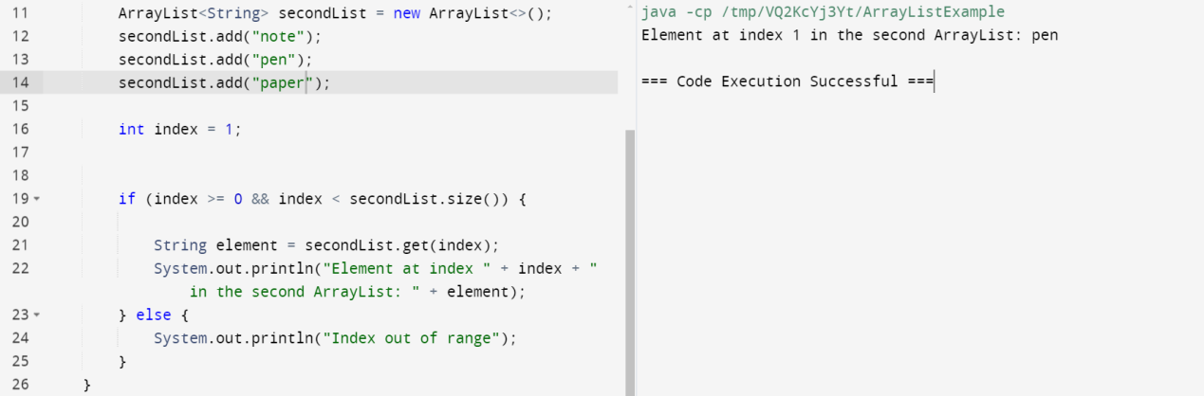

2.To create array list add some colours and printout the collections

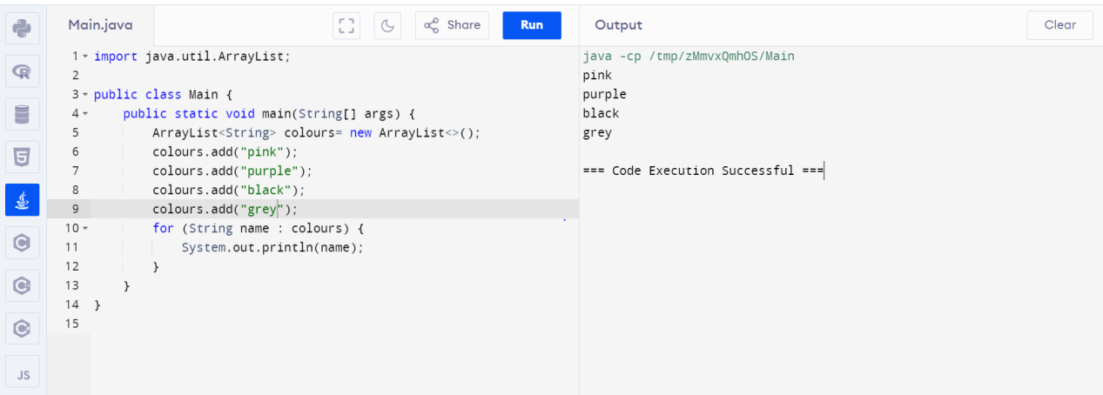

3.reverse the element in the array list

